GEORGIA PRACTICE: 100 % IMMIGATION AND NATURALIZATION LAW
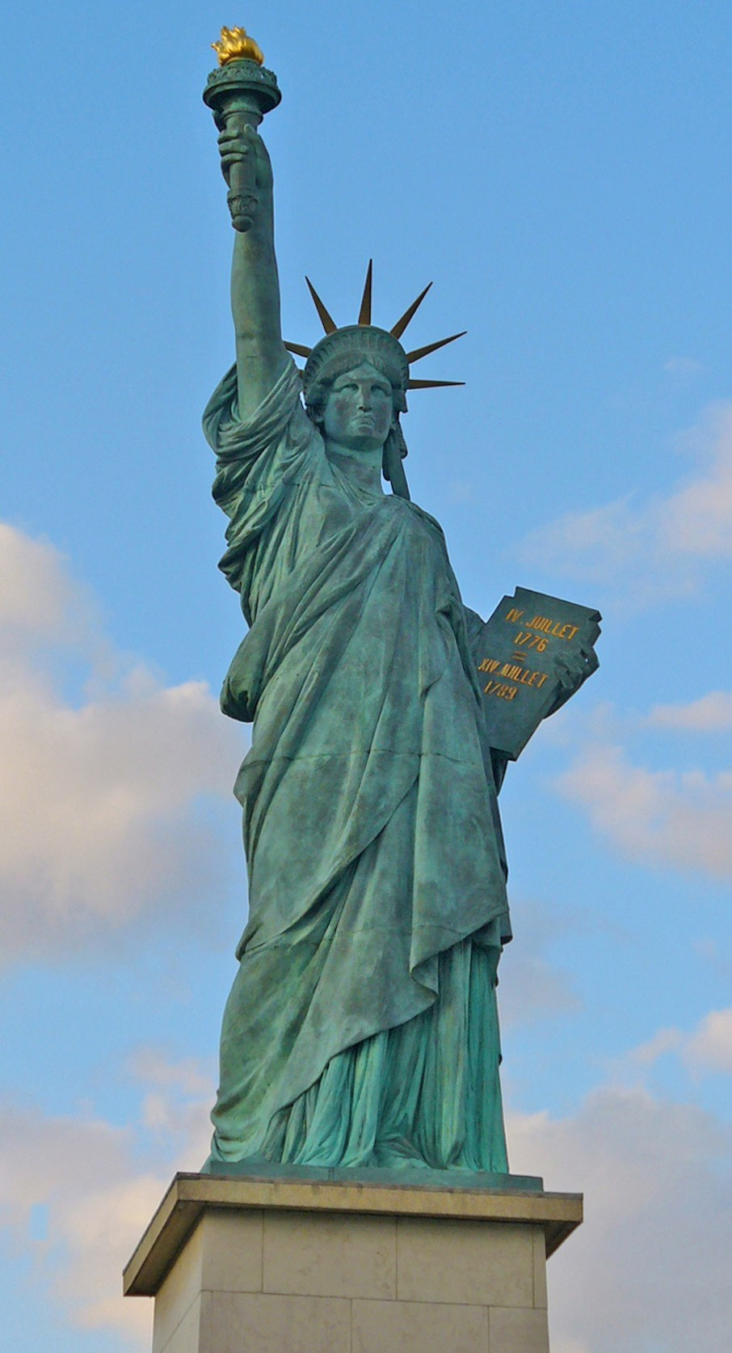
EMPLOYMENT VISA/AUTHORIZATION GREEN CARD
FAMILY IMMIGRATION ASYLUM
REMOVAL / DEPORTATION PROCEEDINGS
U-VISA: For People who have assisted the authorities to prosecute crimes….
T-VISA: For victims of Human Trafficking VAWA: For Victims of Domestic Violence NATURALIZATION
AND, MORE…….

http://www.innocentlaw.com Tel: 678 675 0395
Officine: 5725 Buford Hwy
Fax: 877 823 8052

